A Project

On

University Alumni System

A project submitted in fulfillment of the requirements for the award of the degree of Bachelor of Computer Application



Department of Computer Science

Central University of Orissa,

Koraput

**Submitted by:**

**Ditikrushna Giri (15/04/DCS/02)**

**Dilip Kumar Suna (15/04/DCS/01)**

**Prabin Kumar Patro (15/04/DCS/05)**

**Under Supervision of:**

**CERTIFICATE**

It is certified that the work contained in the project report titled “University Alumni System” by has been carried out under my/our supervision and that this work has not been submitted elsewhere for a degree .

**ACKNOWLEDGMENTS**

**CONTENT**

1. **INTRODUCTION**

**1.1 ABOUT THE SYSTEM**

1.1.1 About CUO

* + 1. About Department

1. **SYSTEM ENVIRONMENT**
   1. Hardware Specification
   2. Software Specification
2. **SYSTEM ANALYSIS**
   1. Existing System
   2. Proposed System
3. **SYSTEM DESIGN**
   1. Context Diagram
   2. Flow Chart
   3. ER-Diagram
   4. Data Dictionary
4. **APENDIX**
   1. Database System
   2. Screen Layout
   3. References

**INTRODUCTION**

**ABOUT THE SYSTEM**

**1.1.1 ABOUT CUO**

The Central University of Orissa has been established by the Parliament under the Central Universities Act, 2009 (No. 3C of 2009). It is one of the 15 new Central Universities established by the Government of India during the UGC XI Plan period to address the concerns of "equity and access" and as per the policy of the Government of India to increase the access to quality higher education by people in less educationally developed districts which have a Graduate Enrollment Ratio of less than the national average of 11%. Koraput District of Orissa comes within the KBK region (Koraput, Bolangir and Kalahandi) which is still considered as an extremely as underdeveloped region of the State of Orissa .These three districts of the State are known for tribal culture, because majority of the people here belong to ST and SC categories. Since there is no University or any other national level educational set up in this region the Central University is proposed to be established here so that it may widen the access to quality higher education in the country.

* + 1. **ABOUT DEPARTMENT**

The department of Computer Science was started in the year 2015. The department currently holds regular programme for Bachelor of Computer Application (BCA).

**Vision, Mission and Goal:**

* To develop quality professionals who are able to compete in the recent trends of Information Technology.
* To make our department a hub for research and development so that the department can grab projects from govt. /private agencies.
* To impart training to the students and faculties from other departments of our University.
* To open new academic programmes like MCA, M.Tech (CSE), M.Sc.(CS) etc.

**SYSTEM ENVIRONMENT**

**2.1 HARDWARE SPECIFICATION**

CPU : CORE i3

Speed : 1.30GHz

Total RAM : 512 MB

Hard Disk : 500 MB

Keyboard : 105 KEYS

Mouse : LOGITECH MOUSE

**2.2 SOFTWARE SPECIFICATION**

##### FRONT END : HTML, CSS, JAVASCRIPT

BACK END : MYSQL , PHP

OPERATING SYSTEM : WINDOWS 7/8/8.1/10

**SYSTEM ANALYSIS**

**3.1 PROPOSED SYSTEM**

The aim of proposed system is to develop a system of improved facilities. The proposed system can overcome all the limitations of the existing system. The system provides data accuracy and save disc space. The existing system has several disadvantages and many more difficulties to work well. The proposed system tries to eliminate or reduce these difficulties up to some extent. The proposed system will help the user to consume time. The system requires very low system resources.

**Advantages of Proposed System University**

The system is very simple in design and to implement. The system requires very low system resources and the system will work in almost all configurations. It has got following features

* This website provides online admission procedure and counseling.
* This website helps all the users to view the list of administrative staff.
* This website provides all the facilities available in the University.
* Login users can take the advantage of the online registration
* The User can follow our website in social media
* User-friendly

**SYSTEM DESIGN**

**4.1 CONTEXT DIGRAM**

User registration,

User login form

Alumni member

Messages

Student

**4.2 FLOW CHART**

**4.2 ER-DIAGRAM**

**4.3 DATA DICTONARY**

**student .db**

|  |  |  |  |
| --- | --- | --- | --- |
| **Field Name** | **Field Type** | **Field size** | **Description** |
|  |  |  |  |
| user_id | Varchar | 50 | Primary key P |
| password | Varchar | 50 | ----- |
| email | Varchar | 30 | ----- |
| contact_no | Int | 11 | ----- |
| current_org_name | Varchar | 50 | ----- |
| current_org_address | Text | ----- | ----- |
| city | Varchar | 50 | ----- |
| state | Varchar | 50 | ----- |
| country | Varchar | 50 | ----- |
| schoolname | Varchar | 50 | ----- |
| branch | Varchar | 50 | ----- |
| passingyear | date | ----- | ----- |

**APENDIX**

**5.1 DATA BASE SYSTEM**

**5.2 SCREEN LAYOUT**

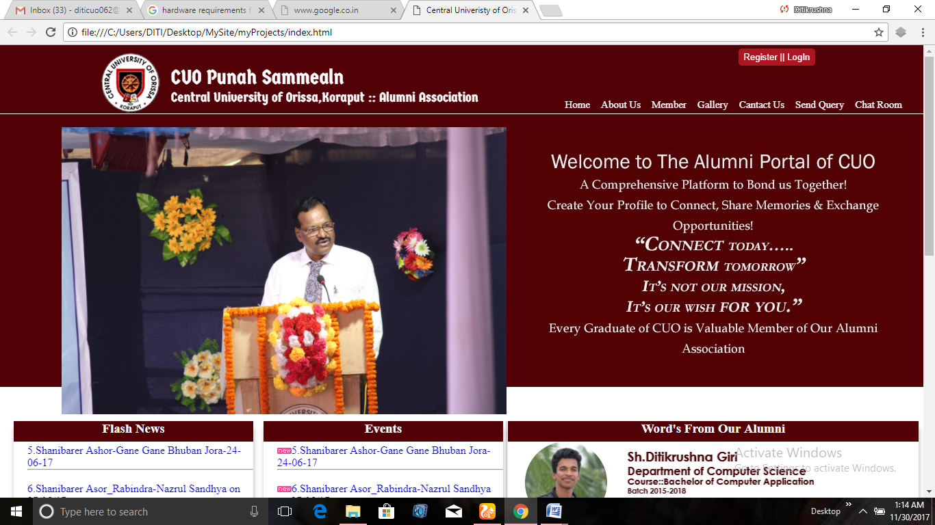

LAYOUT -1 (HOME MODULE)

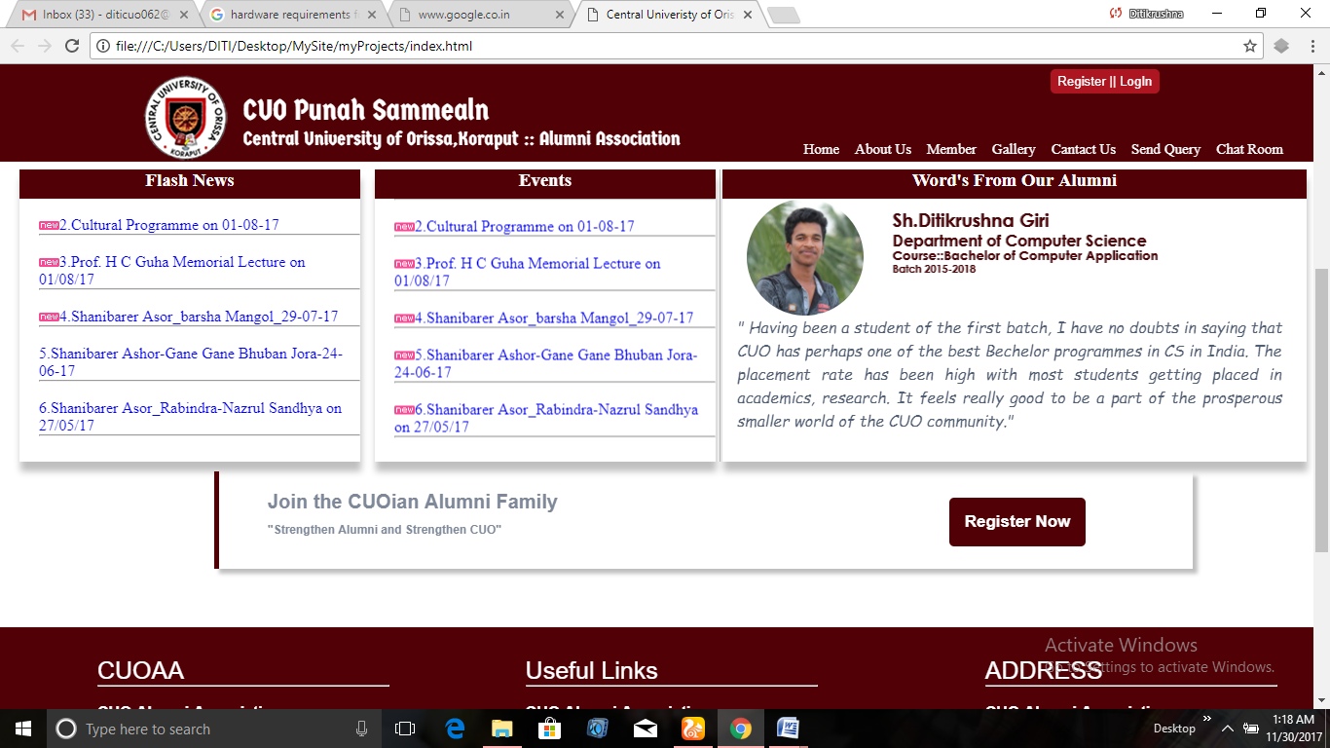

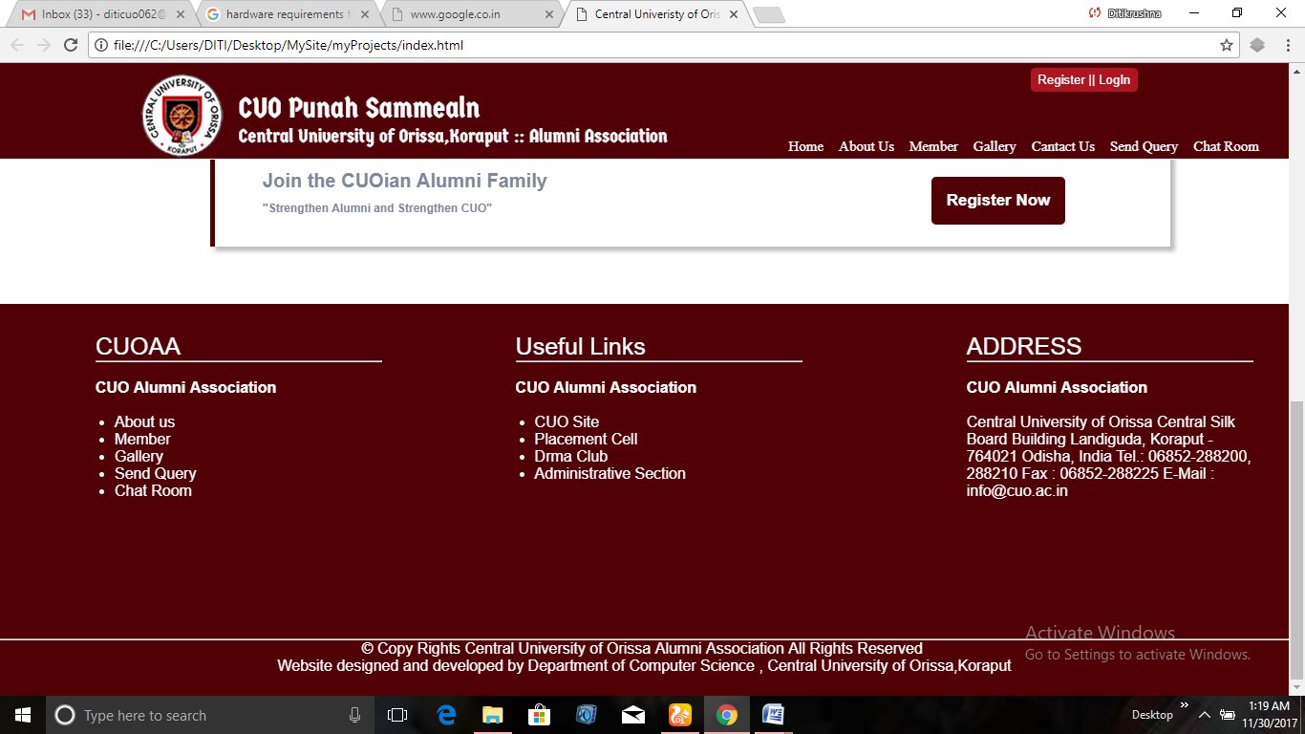

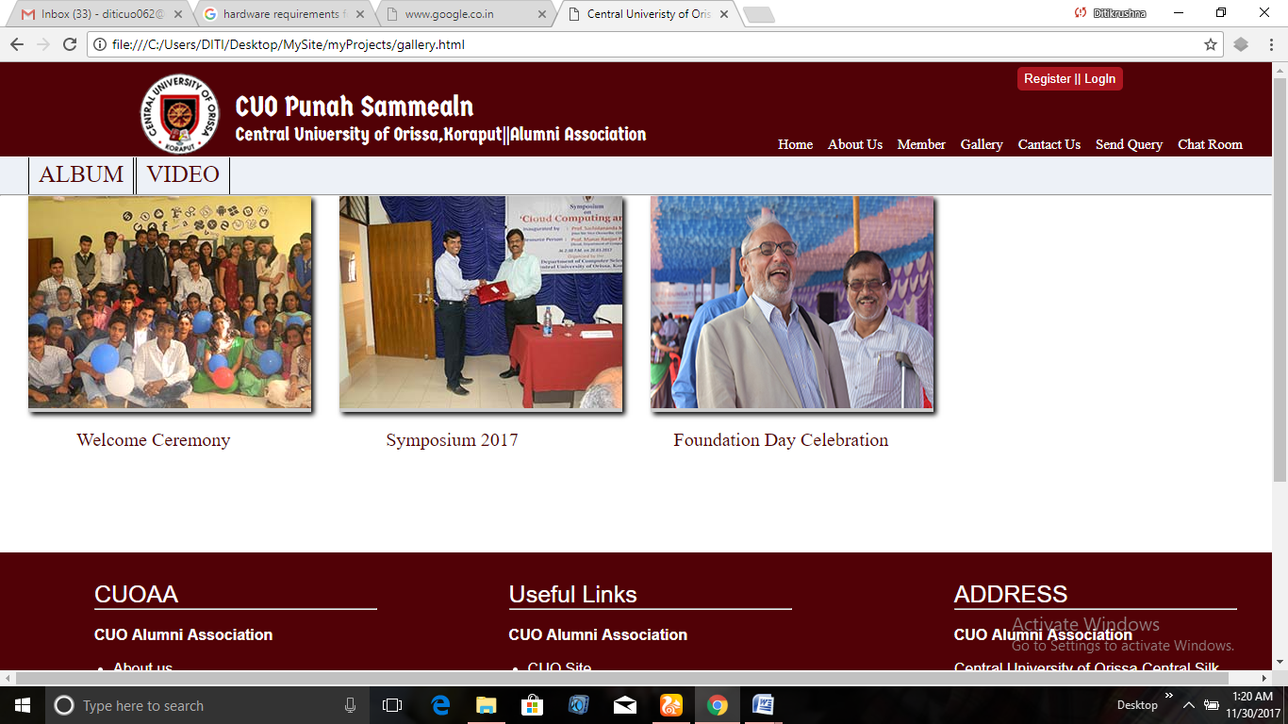

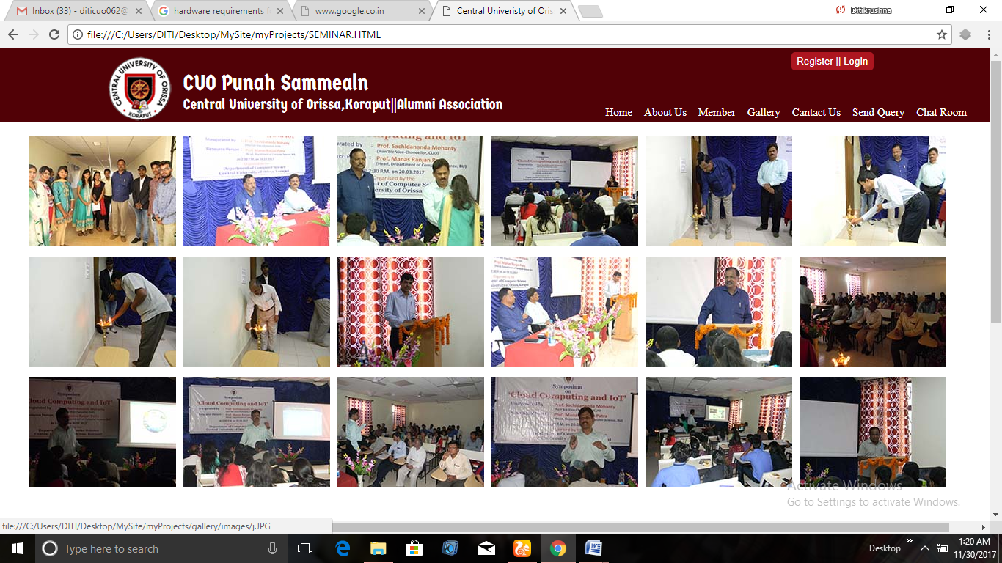

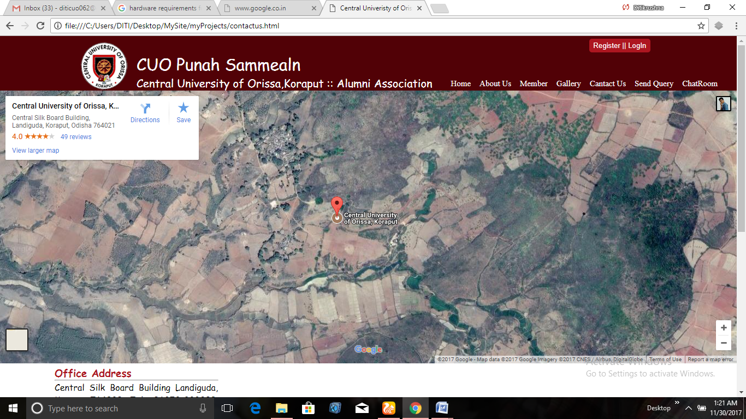

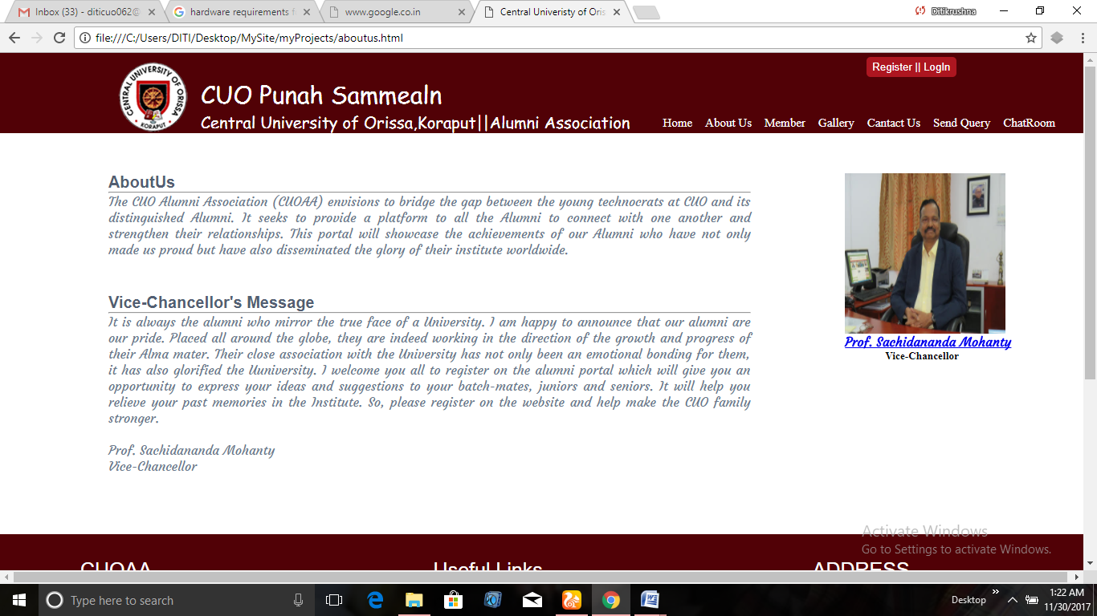

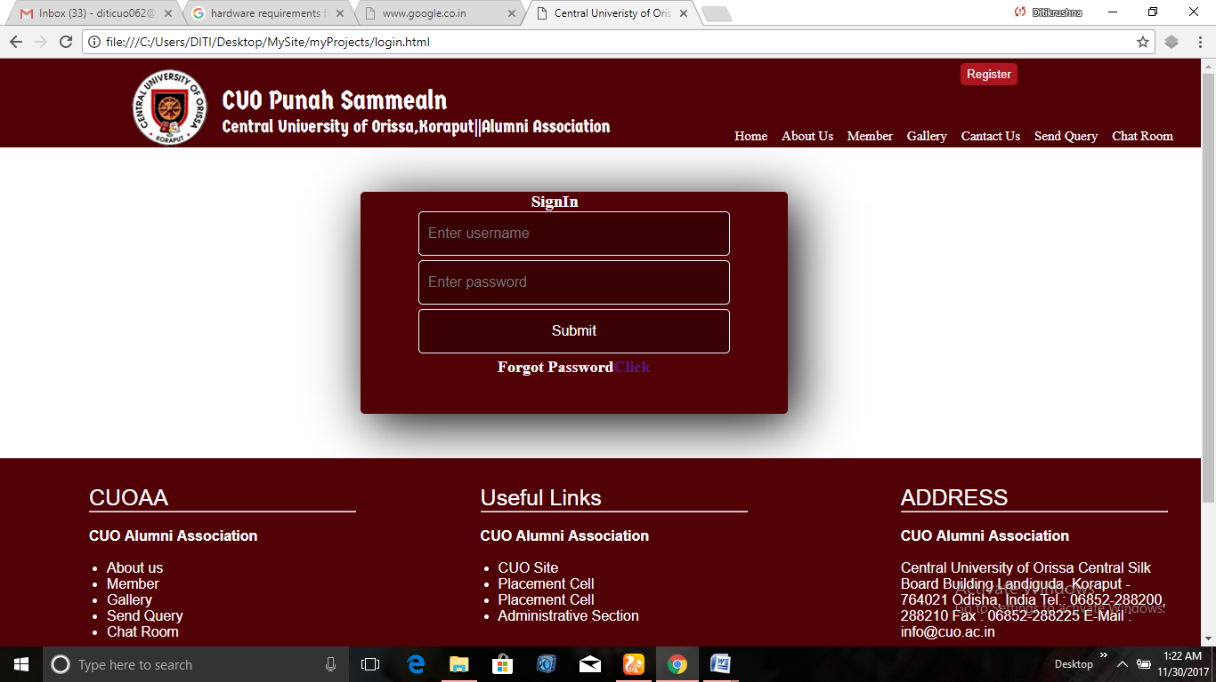

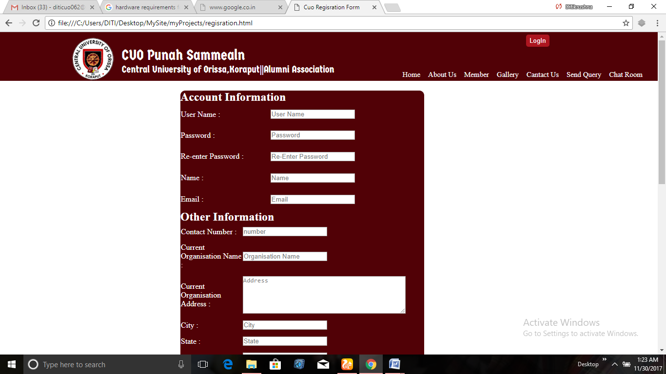

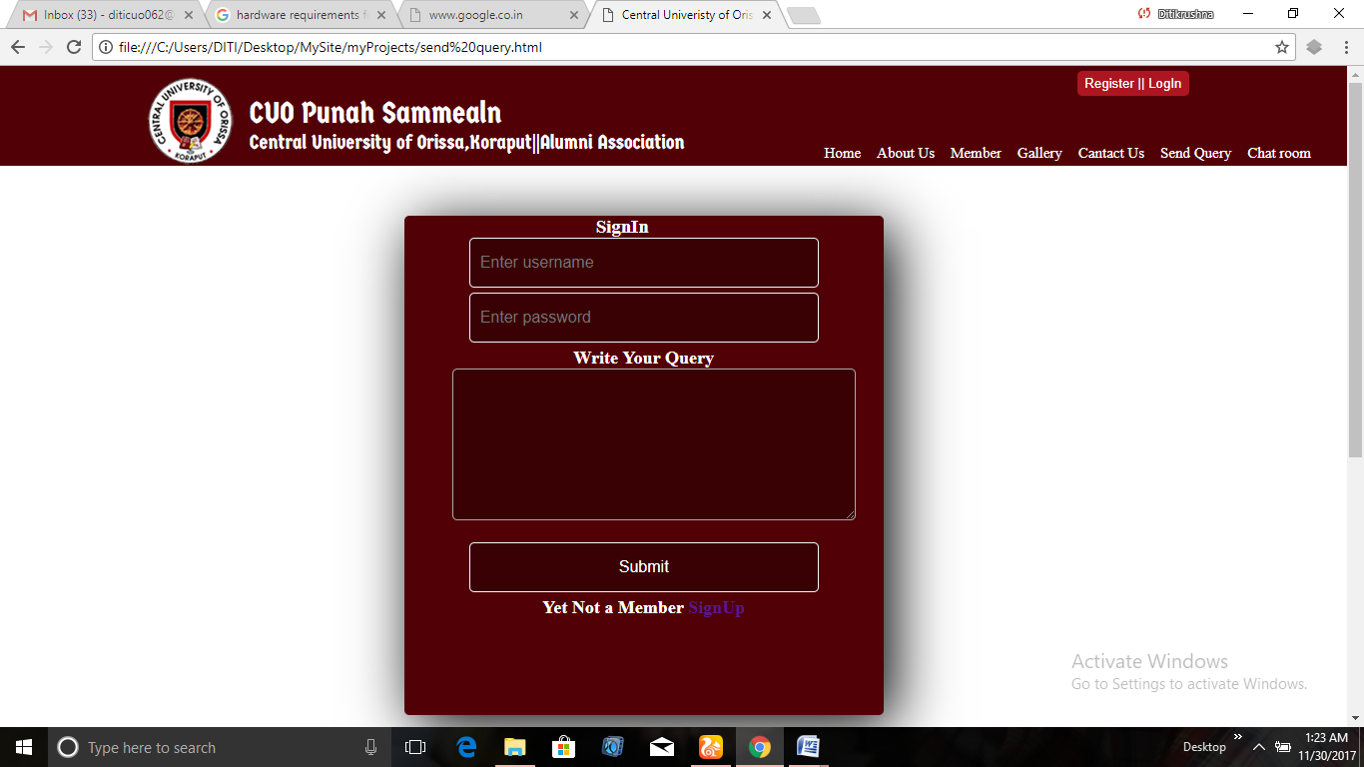

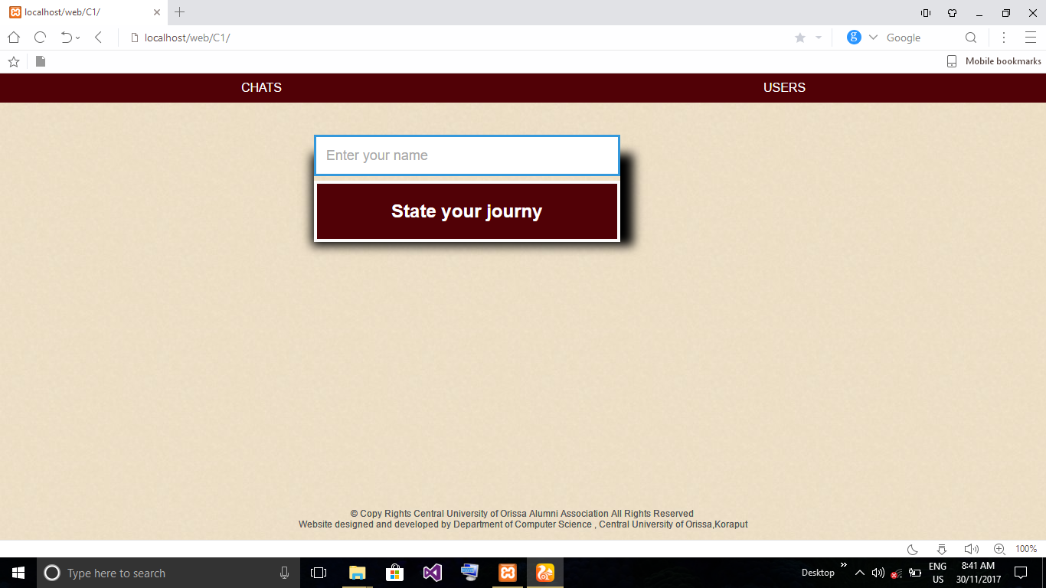

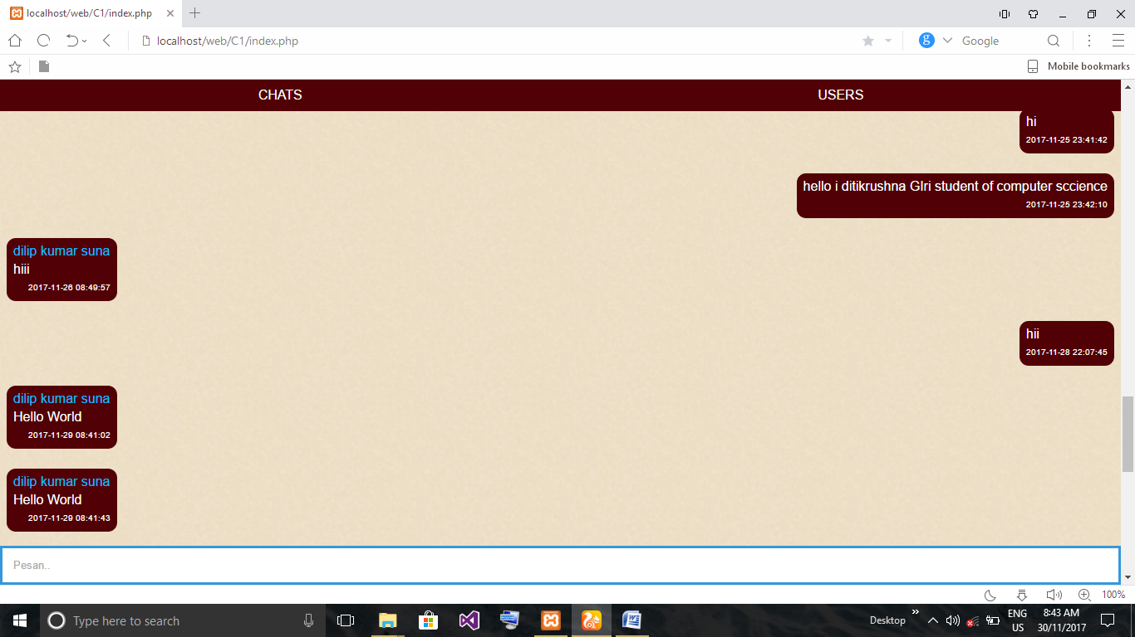

**5.3 REFERENCES**

* [**http://www.w3schools.com**](http://www.w3schools.com)
* [**http://stackoverflow.com**](http://stackoverflow.com)
* [**http://quora.com**](http://quora.com)
* [**The Official Alumni Network of C. V. Raman Group of Institutions**](https://alumni.cvrgi.edu.in/)

**(**[**http://alumnicvrgi.edu**](http://alumnicvrgi.edu)**)**

* [**KIIT Alumni Association**](http://kiitalumni.com/)**(**[**http://kiitalumni.com**](http://kiitalumni.com)**)**